Abstract
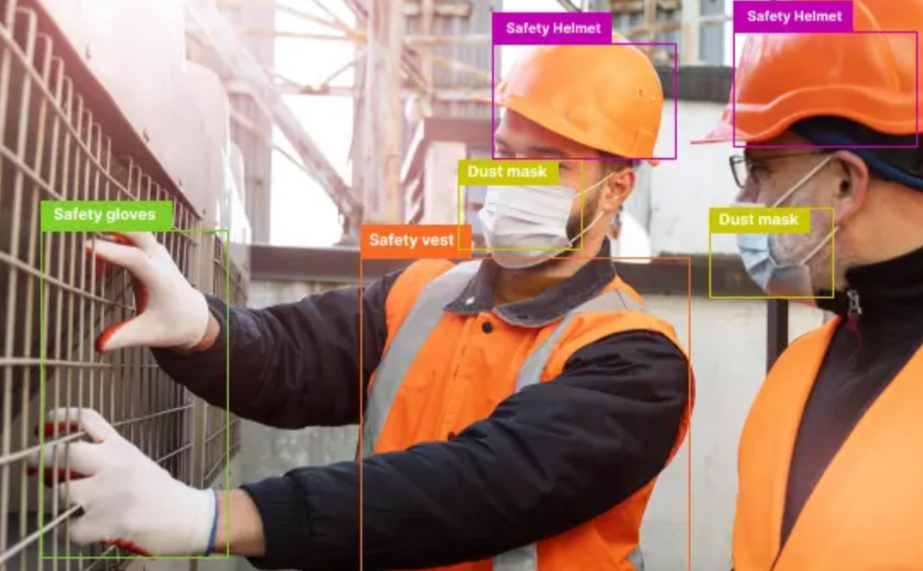  Construction Safety Monitoring System  Shahd Ahmed Ali – 233341||Mohamed Ibrahim – 236671 | Dr. Rabab  Big-Data CS-455  12/15/2025

This project presents a Construction Safety Monitoring System that automatically checks whether workers on a construction site are wearing their basic personal protective equipment (PPE), focusing on safety helmets and reflective vests. we tried several model variants (YOLO v8n, v8x, v11n and v11x) and found that YOLO v11x gave the best overall performance, so we used it as the final model and report its accuracy and confusion matrix. The system is built around a YOLOv11x object detection model trained on the Construction Site Safety Image Dataset (Roboflow/Kaggle), which contains labelled images of real construction scenes. When the user provides an image or a video frame, the model detects people, helmets and vests, and then estimates whether each worker appears compliant or possibly non-compliant with PPE rules. The system then displays the original and annotated images through a simple graphical interface, together with summary statistics such as total workers detected and how many of them seem to meet PPE requirements. From our experiments, the model performs well in normal conditions but its accuracy decreases when workers are far from the camera, partially hidden or when the image quality is poor. Overall, the project shows that combining deep learning and computer vision can support construction safety officers by making PPE monitoring faster and more consistent than manual observation alone.
1.Introduction
Construction sites are busy places, with many workers, machines, and activities going on at the same time. Because of this, accidents can happen easily, especially if workers are not wearing their safety gear properly. Things like helmets and reflective vests are basic PPE, but in reality, some workers ignore them or remove them during work. Usually, safety engineers or supervisors try to watch what is happening on site, but it is impossible for them to monitor every worker and every camera all day. This is where computer vision can help In this project, we build a system that can automatically check PPE from images or camera frames using a YOLO-based deep learning model, where we experiment with different versions and finally select YOLO v11x as the best-performing model. Here is Correct vs incorrect PPE detection:

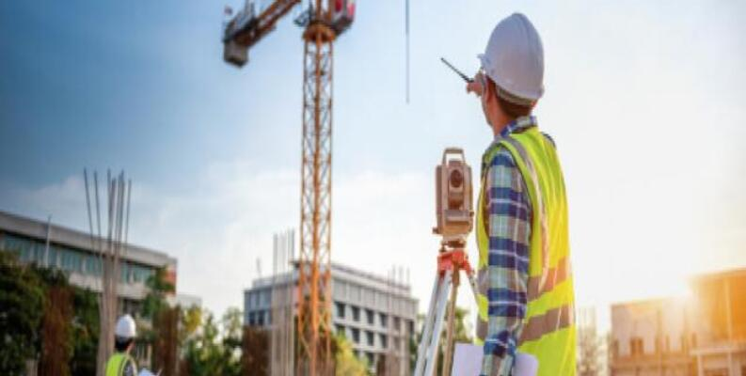
Purpose and Objectives:
- Detect workers in construction images/videos.
- For each detected worker, use the dataset labels (Helmet, Gloves, Vest, Boots, Goggles, none, Person, no_helmet, no_goggle, no_gloves, no_boots) to decide whether they are compliant or non-compliant with PPE rules. Highlight compliant and non-compliant workers in the image.
- Show statistics (for example: total workers, wearing PPE, not wearing PPE).
2. Background and Literature Review
Many researchers have tried to use deep learning to improve safety on construction sites. Fang et al. (2021) built a system for real-time helmet detection from video. Their model reached high accuracy and showed that automatic helmet monitoring is possible in practice. Kim and Lee (2020) extended this idea to more PPE items like helmets and harnesses. They used Faster R-CNN with site cameras and generated alerts when PPE was missing. Their system reduced the need for constant manual checking. Zhou and Chen (2022) used YOLO-based models to monitor PPE compliance. They fine-tuned YOLOv5 on construction images and reported good mAP scores while still running in real time. This work is close to our project since we are also using a YOLO model. Wang et al. (2021) compared different YOLO versions and found that YOLOv5s gives a good balance between speed and accuracy for PPE detection. Lee et al. (2023) later compared YOLOv3, v4, and v7 and concluded that YOLOv7 performs best for helmets and vests. For our project, we use the Construction Site Safety Image Dataset from Kaggle (Sanyal, 2022). This dataset contains labelled images of people, helmets, and safety vests in real construction environments. It is already prepared in a format that works well with YOLO, which makes it convenient for training and testing our model.
3. Problem Statement
On many construction sites, PPE rules exist on paper but are not always followed. Supervisors may miss violations, especially when the site is large or there are many cameras to watch. This creates a gap between the safety plan and what happens on the ground. So, the problem we address in this project can be written as: to design and implement a system that uses YOLO-based models and a construction safety image dataset to automatically detect workers and identify whether they are wearing their helmet and reflective vest, helping safety teams monitor PPE more easily.

4. System Requirements / Tools Used
- Operating system: Windows 11
- Python: 3.13
- IDE / tools: VS Code and Jupyter Notebook.
- Deep learning toolkit: Ultralytics YOLO (YOLOv8 / YOLOv11) on top of PyTorch
- Frontend: Streamlit web app for the GUI
- Big data / processing: Apache Spark (used for handling and analysing detection logs and results in a scalable way)
- Containerisation: Docker (used to package the model, dependencies and Streamlit app into a portable container)
- Other tools: Kaggle (for downloading the dataset), GitHub/Google Drive for saving models and results
Languages and Frameworks
- Python
- Deep learning backend: PyTorch (through YOLO-based models: YOLO v8 and YOLO v11 variants)

5. Methodology / Approach
The project was done in several stages. Below is a explanation of how we approached it.
A. Dataset
We downloaded the Construction Site Safety Image Dataset from Kaggle. The dataset has images of construction workers, with labels for:
- Helmet
- Gloves
- Vest
- Boots
- Goggles
- None
- Person
- no_helmet
- no_goggle
- no_gloves
- no_boots
The dataset is already compatible with YOLO format (images + .txt labels). We split it into training, validation, and test sets.
B. Model: YOLO Variants (v8 and v11)
We used YOLO models from Ultralytics because they are easy to use and give good performance. In particular, we experimented with four versions: YOLO v8n, YOLO v8x, YOLO v11n and YOLO v11x. All of them were fine-tuned on our construction safety dataset. After comparing their performance, we found that YOLO v11x achieved the best results, so it was chosen as the final model, and we report its accuracy and confusion matrix in the results section.

C. Training Steps
- Configure a YAML file with the path to our dataset and the class names.
- Choose training hyperparameters (epochs, batch size, image size, etc.).
- Train the YOLO models (v8n, v8x, v11n, v11x) and monitor loss, precision, recall, and mAP on the validation set for each version.
- Save the best model weights for YOLO v11x.

D. Detection and Interface
- Select or upload an image/video.
- Run the YOLOv11x model on it.
- See an output image with bounding boxes and labels around people, helmets, and vests.
We also count how many workers are fully compliant (person + helmet + vest) and how many are missing something and show that in a small text or chart.

E. Simple Dashboard
We added a dashboard that shows:
- Total workers
- Workers with full PPE
- Workers missing helmets
- Workers missing vest

6. System Design
6.1.System Architecture Diagram:
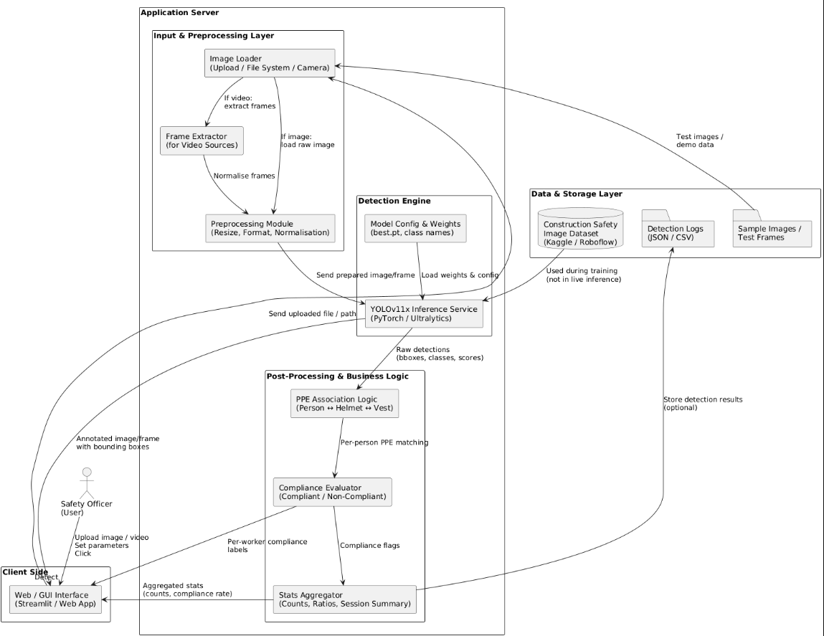
This diagram illustrates the main components of the system: input images/video, the YOLO-based detection engine (with YOLO v11x as the final selected model), post-processing logic that checks PPE compliance, and the user interface, which displays the annotated frames and safety statistics.

6.2. Sequence Diagram:
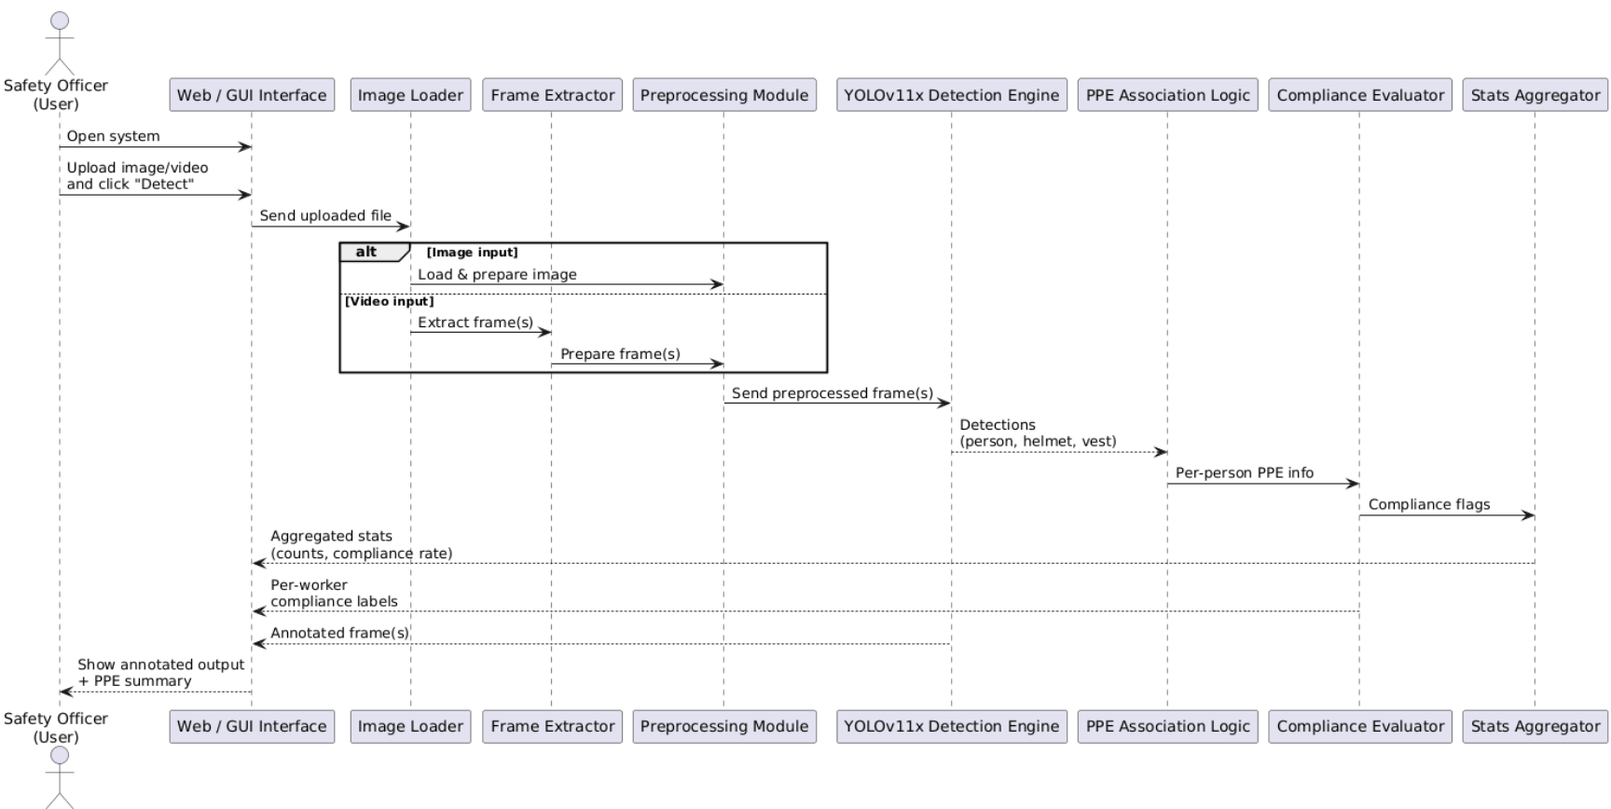
This diagram shows how the user, the GUI interface, and the YOLO-based model interact. The user uploads an image or video and clicks detect, the interface sends it to the model, receives the PPE detections, and then returns the annotated output and summary back to the user.

7.Implementation
System Interface:
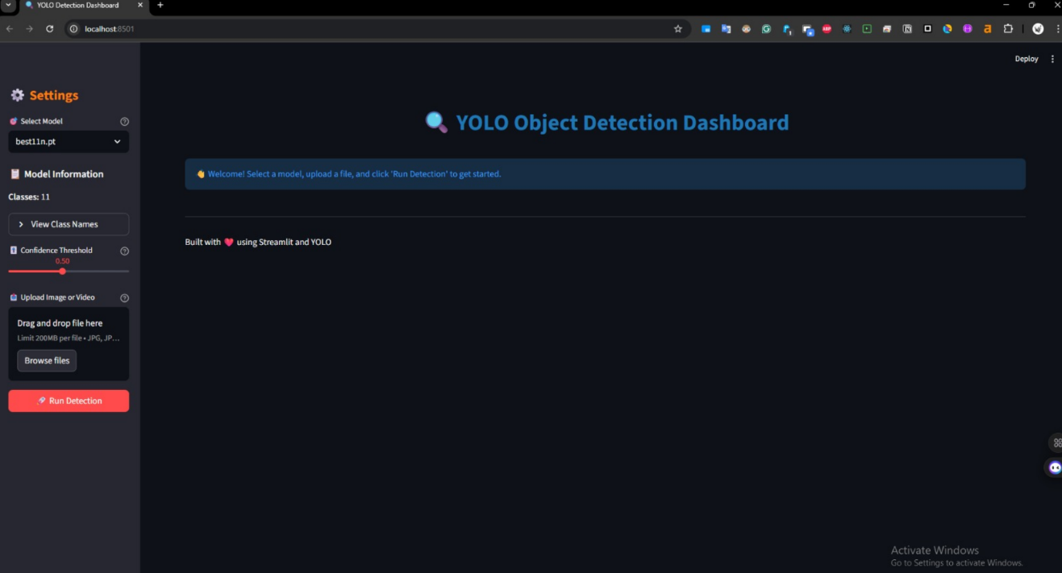

Code Snippets:
Snippet 1 – Base YOLO training:
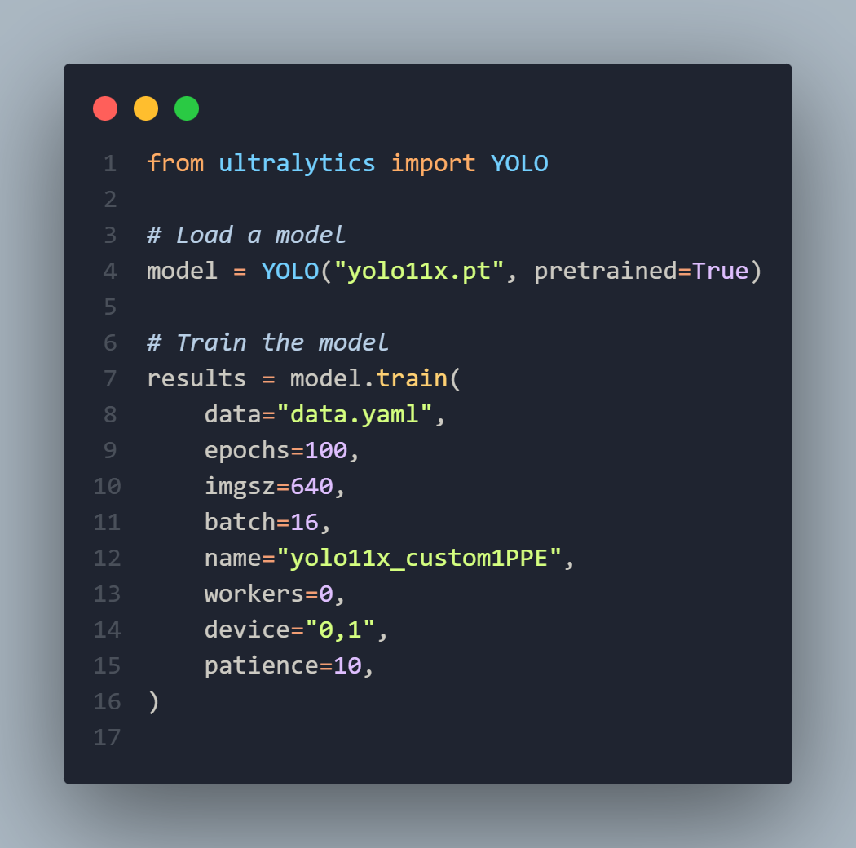
Snippet 2 – Fine-tuning several models and choosing the best:
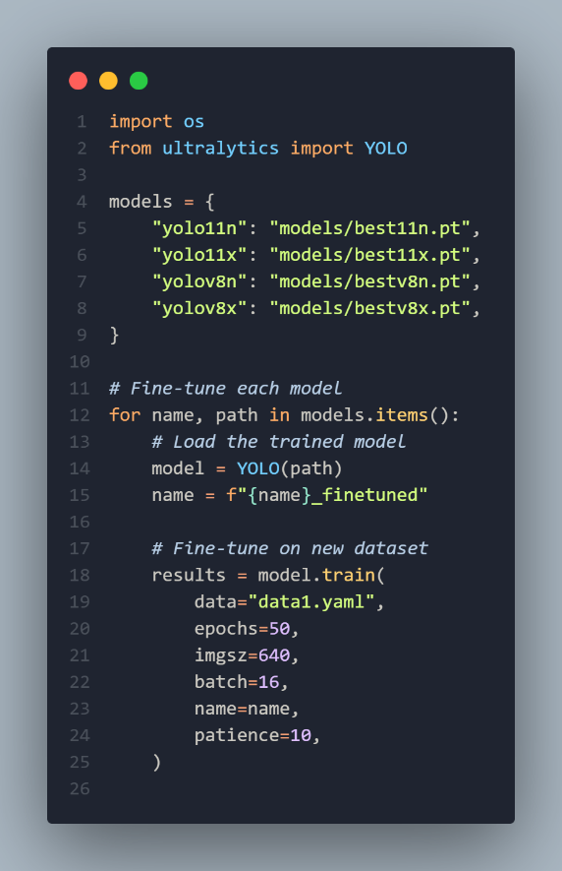
Snippet 3 – GUI: model selection, upload & detection:
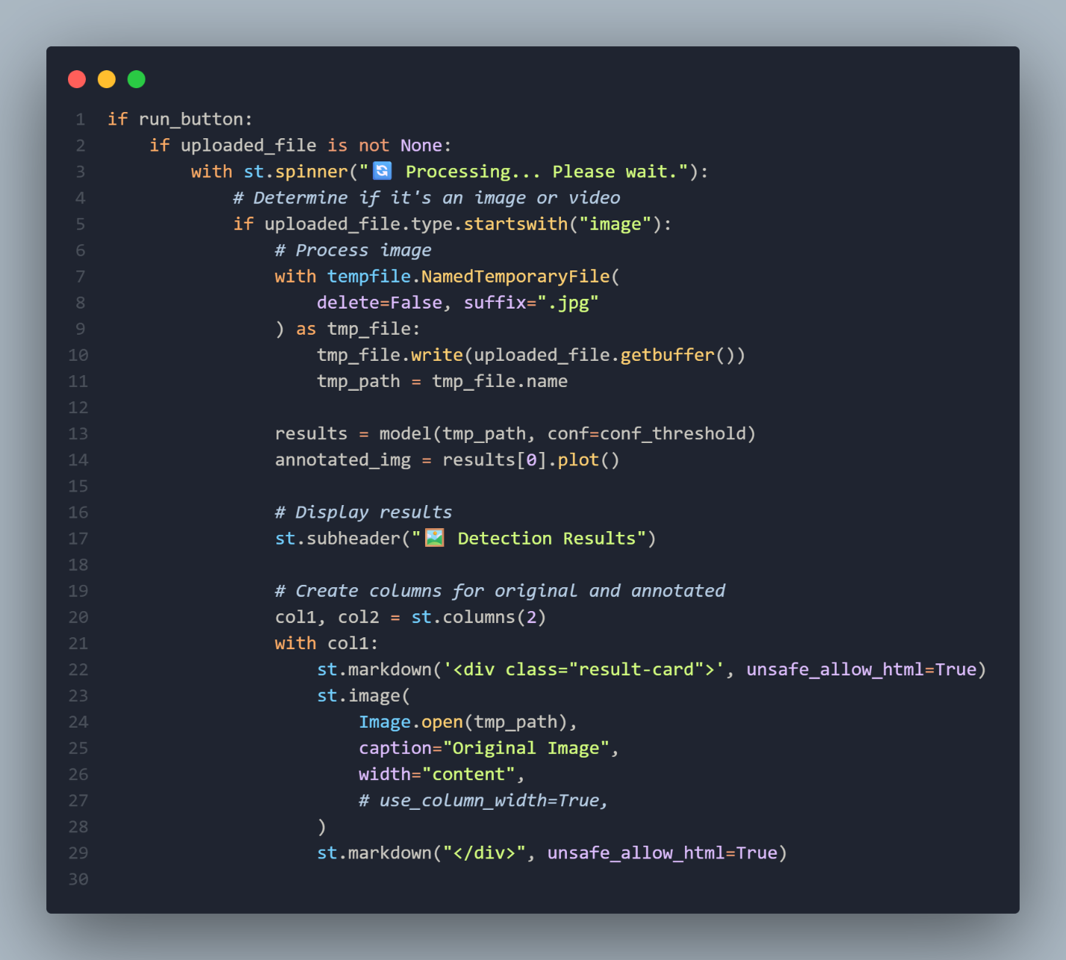

Explanation of Features
Our system is kept simple so a safety officer can use it easily:
- Upload and detect: The user just uploads a construction image or short video and presses a Detect button.
- Automatic PPE recognition: The model then finds people and the PPE classes from the dataset (hardhat, no-hardhat, safety vest, no-safety vest, person, safety cone, machinery, vehicle).
- Clear visual result: The output is shown with colored boxes and labels, so it’s easy to spot who is safe and who might be missing equipment.
- Quick summary: Under the image, the system shows a small summary (how many workers, how many look compliant, how many do not), so the user gets a quick idea of the situation without checking every box.
8. Results & Testing
We tested the model on:
• The test split of the dataset.
• Some random images from the dataset that were not used in training.
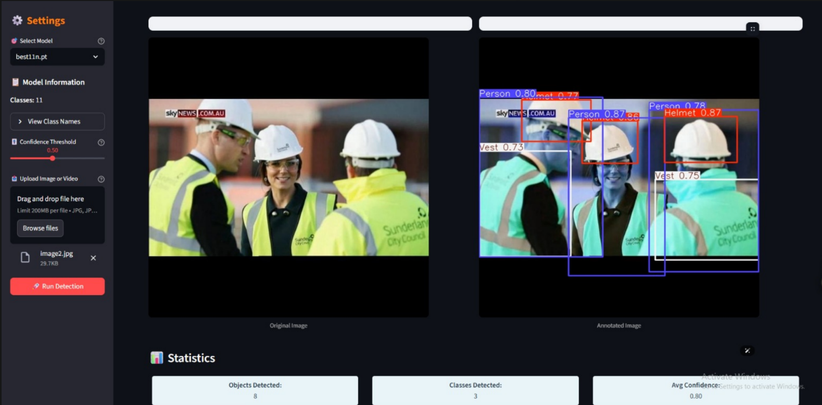We looked at both the numbers (like mAP and precision on helmets and vests) and the visual output. During evaluation, we compared the performance of YOLO v8n, YOLO v8x, YOLO v11n and YOLO v11x. Among these, YOLO v11x gave the best overall results in terms of accuracy and confusion matrix, so we decided to present only its detailed metrics and confusion matrix in our report. For many normal images with clear lighting and visible workers, the final YOLO v11x model performed well. It usually detects the person, helmet, and vest correctly.
Problems encountered and how we solved them:
- Training was slow on our hardware:
The bigger YOLO models took too long and sometimes made the notebook freeze. We fixed this by shrinking the image size, lowering the batch size, and running quick tests with lighter models first. Then we trained only the best option longer.
- Different YOLO versions gave mixed results:
Some versions worked well on some PPE classes but not others. To be fair, we kept the same dataset split and settings for every model, compared results side by side, and finally chose YOLO v11x because it performed best overall.
- Weak detection for “no-PPE” classes (low recall):
Classes like no_helmet / no_gloves / no_goggle had fewer examples, so the model missed them more often. We used simple augmentation (flip/rotation) and slightly lowered the confidence threshold for those classes during testing, which helped.
- Small or far workers were harder to detect:
When people were far from the camera, helmets and vests were easy to miss. We improved this by testing higher inference resolution and tuning confidence + IoU thresholds until detections became more stable.

Confusion Matrix:
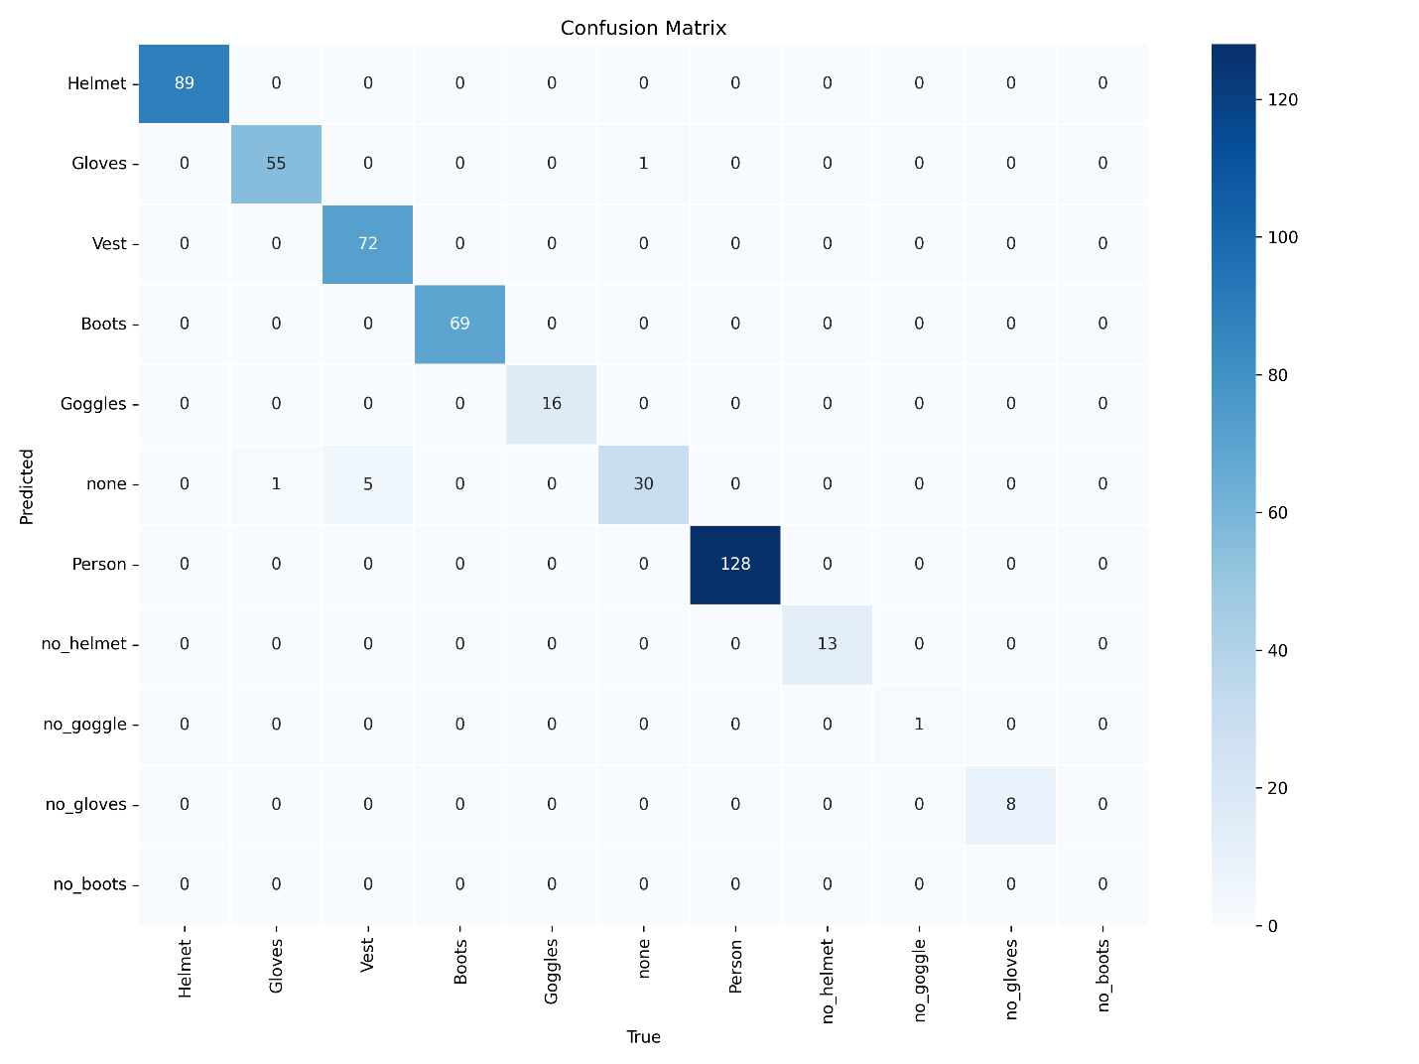
Class | Precision | Recall | F1-score | Support
Helmet | 0.99 | 1.00 | 0.99 | 89
Gloves | 0.92 | 0.98 | 0.95 | 56
Vest | 1.00 | 1.00 | 1.00 | 72
Boots | 1.00 | 1.00 | 1.00 | 69
Goggles | 1.00 | 1.00 | 1.00 | 16
none | 1.00 | 0.83 | 0.91 | 36
Person | 1.00 | 1.00 | 1.00 | 128
no_helmet | 0.93 | 1.00 | 0.96 | 13
no_goggle | 1.00 | 1.00 | 1.00 | 1
no_gloves | 1.00 | 1.00 | 1.00 | 8
no_boots | N/A | N/A | N/A | 0
Precision ≈ 0.98
Recall ≈ 0.98
F1-score ≈ 0.98
accuracy ≈98.57%
9. Discussion
From this project, we saw that using YOLO-based models with a labelled dataset can give good results without needing to build everything from scratch. The idea of using object detection for PPE monitoring is practical and realistic.
Things that worked well:
• Using a dataset that is already annotated saved a lot of time.
• The Ultralytics API for YOLO (v8 and v11) is simple, so training and testing different variants (v8n, v8x, v11n, v11x) was straightforward.
• Visual outputs (bounding boxes and labels) make the system easy to understand and explain.
Challenges we faced:
• Making the model generalise to different lighting and camera angles.
• Deciding how to define compliance, for example, is a worker compliant if only the helmet is detected but the vest is partially hidden?
• Running training on limited hardware takes time, especially when testing several model versions like v8n, v8x, v11n and v11x.
In the future, we would like to:
- Add more PPE types.
- Use more diverse data, especially night images.
10. Conclusion
In this project, we developed a Construction Safety Monitoring System using YOLO-based models and a construction safety image dataset from Kaggle. We experimented with multiple versions (YOLO v8n, YOLO v8x, YOLO v11n and YOLO v11x) and selected YOLO v11x as the final model because it achieved the best performance. The system can detect workers and use all the dataset labels—Helmet, Gloves, Vest, Boots, Goggles, none, Person, no_helmet, no_goggle, no_gloves, no_boots—to check whether each worker is compliant with PPE rules, then show the result visually and in a simple statistical way. Through this work, we learned how to work with a real-world labelled dataset, how to fine-tune and compare different YOLO models, and how to build a simple interface to run detection and display the results clearly.

11. References
1.Fang, W., Ding, L., & Luo, H. (2021). Real-time detection of construction workers’ helmet wearing using deep learning. Automation in Construction, 124, 103556.
2.Kim, S., & Lee, D. (2020). Computer vision system for monitoring safety equipment in construction environments. Advanced Engineering Informatics, 45, 101104.
3.Zhou, Y., & Chen, J. (2022). PPE compliance monitoring on construction sites using YOLO-based models. Journal of Safety Research, 80, 1–12.
4.Wang, Z., Wu, Y., Yang, L., Thirunavukarasu, A., Evison, C., & Zhao, Y. (2021). Fast personal protective equipment detection for real construction sites using deep learning approaches. Sensors, 21(10), 3478.
5.Lee, J.-H., Lee, L.-K., & Hsu, C.-C. (2023). Real-time personal protective equipment compliance detection based on deep learning algorithm. Sustainability, 15(1), 391.
6.Sanyal, S. (2022). Construction Site Safety Image Dataset (Roboflow) [Dataset]. Kaggle.

12. Appendix:
Here is the link of our GitHub that contains the folder of the project.
https://github.com/Mohamed-Ibrahim183/Congratulations_Safety

Thank You

